## FPT ACADEMY INTERNATIONAL FPT – APTECH COMPUTER EDUCATION



### Centre Name: ACE-HCMC-2-FPT.

**Address: 590 Cach Mang Thang 8, District 3, Ho Chi Minh City, Viet Nam.**

The Cosmic Discoveries

|  |  |  |
| --- | --- | --- |
| **Supervisor:** | Ms. Le Mong Thuy | |
| **Semester:** | 1 | |
| **Batch No:** | T1.2406.M1 | |
| **Group No:** | 6 | |
| **Order:** | **Name** | **Student ID** |
| 1. | Le Nguyen Gia Huy | Student1571995 |
| 2. | Dang Quoc Khanh | Student1572003 |
| 3. | Tran Trung Anh | Student1571996 |
| 4. | Nguyen Hoang Dung | Student1515873 |

Date: September - 2024

### This is to certify that

**Mr.** Le Nguyen Gia Huy

**Mr.** Dang Quoc Khanh

**Mr.** Tran Trung Anh

**Mr.** Nguyen Hoang Dung

### have successfully designed & developed:

eProject: The Cosmic Discoveries

### Submitted by:

Ms. Le Mong Thuy

**Date of issue:** Oct 14th 2024

### Authorized Signature:

**Table of Contents**

ACKNOWLEGMENT 3

SYNOPSIS 3

ANALYSIS 3

1. Purpose of the Website 3
2. Design and Interface 3
3. Technical Requirements 4

CUSTOMER'S REQUIREMENTS SPECIFICATIONS 4

1. Business/Project Objective 4
2. Hardware/ Software Requirements 5
   1. Hardware 5
   2. Software 5

SCOPE OF THE WORK (IN BRIEF) 6

1. Home 6
2. Cosmic Discoveries 6
   1. Big Bang Theory 6
   2. Evolution of Earth 6
   3. Planets 6
   4. Constellations 6
   5. Comets 6
3. Latest Developments 6
4. Observatories 6
5. Libraries 6
6. Contact: Contact information for users to reach out or send feedback 6

ARCHITECTURE AND DESIGN OF THE SYSTEM 7



DIAGRAM OF THE WEBSITE 8

TASK SHEET REVIEW 1 9

SITE MAP 10

MOCK OF THE WEBSITE 11

1. Home 11
2. Cosmic Discoveries 12
   1. Big Bang Theory 12
   2. Evolution of Earth 12
   3. Planets 12
   4. Constellations 12
   5. Comets 12
3. Latest Developments 13
4. Observatories 14
5. Libraries 15

Contact: Contact information for users to reach out or send feedback 16

TASK SHEET REVIEW 2 17

WEBSITE DESCRIPTION

1. Home 18,19
2. Cosmic Discoveries 20
   1. Big Bang Theory 20
   2. Evolution of Earth 21
   3. Planets 22
   4. Constellations 22,23
   5. Comets 23,24
3. Latest Developments 25
4. Observatories 26
5. Libraries 27

5.1 Images 27

5.2 Videos 27

5.3 Books 28,29

1. Contact: Contact information for users to reach out or send feedback 30

TASK SHEET REVIEW 3 31

## ACKNOWLEGMENT

On behalf of team members. I would like to thank everyone who supported my team to successfully complete this eProject report. Especially, our teacher, she has supported us a lot since we started studying at FPT Aptech. With this eProject, she guided us very meticulously, enthusiastically and strictly. With her guidance, we were able to successfully complete this project. Besides, I also want to thank all the team members, each of whom worked hard to complete the eProject in earnest during the month of working together. Finally, our group would like to say thank you to my classmates and family for sharing and creating for the group the best environment to focus on the project, motivating the members to achieve their goals.

## SYNOPSIS

## Astronomy is a scientific field that studies celestial objects and phenomena in the universe. It is one of the oldest sciences and includes many subfields, ranging from observing planets and stars to studying the structure and evolution of the universe. Here is a summary of some key aspects of astronomy:

## Celestial Objects: Stars, Planets, Galaxies, Nebulae.

## Astronomical Phenomena: Supernova, Black Holes, Gravitational Lensing.

## Research and Tools: Telescopes, Space Observatories.

## Universe and Origins: Big Bang, Expanding Universe.

## Modern Exploration and Research: Search for Exoplanets, Dark Matter and Dark Energy Research.

## ANALYSIS

### Purpose of the Website.

The website aims to provide an informative and engaging platform for users to explore various aspects of astronomy. This website will serve as a comprehensive resource, offering detailed information on planets, constellations, comets, astronomical theories, and the latest developments in the field.

### Design and Interface.

* + The website features a user-friendly environment and navigation. Key menus are positioned at the top for easy access to information.
  + The interface and color scheme are harmoniously combined to create a visually appealing and engaging experience for users.

### Technical Requirements

* + The website must perform well across all major browsers including Chrome, IE, Firefox, etc., ensuring accessibility from various devices and platforms.
  + It utilizes a Single-Page-Application (SPA) approach to deliver a seamless and fast web browsing experience.
  + Features are designed to meet technical requirements, facilitating quick and accurate loading and display of information.

## The space exploration website aims to become a valuable and engaging source of information for space enthusiasts, providing everything from basic knowledge to practical insights from researchers and major space research agencies around the world.

## CUSTOMER'S REQUIREMENTS SPECIFICATIONS

### Client: APT India Co.

### Business/Project Objective

The portal will be designed as a Single-Page-Application and responsive Website with a set of pages and menus that represent choice of activities to be performed. The pages, menus, and other visual elements must be designed in a visually appealing manner with attractive fonts, colors, and animations.

All of these should also be laid out in a responsive manner

The Web site is to be created based on the following requirements.

1. There should be detailed information about Astronomy.
2. The website must also include the details mentioned below related to the fields of astronomy.
   * Big Bang Theory, Evolution of Earth.
   * Planets, Constellation, Comets.
   * Latest Developments.
   * Observatories.
   * Educational, Books.

3) Various records related to it should also be provided.

4) The website must also provide details of the organizations/agencies/headquarters along with their locations that will be displayed using GeoLocation API (e.g. GoogleMaps) to arrange astronomical exploration to different locations in different regions around the globe. Users can also see information about astronomical phenomena and space search and exploration activities.

5) There should be a gallery section containing informational/related videos and images

6) There should be a separate section devoted to the documentation of the latest developments in this field.

7) General guidelines are also needed.

8) Additionally, each link must be linked properly; Images must be used whenever necessary.

Over and above this, the portal should implement the following functionalities:

* Display a continuous scrolling ticker at the bottom of the page with current date, time, and location (hint: Use geolocation features of HTML5).
* Display a visitor count at the top right corner of the page beside a logo image.
* The menu options should change color on hover and also after clicking.
* Fade in and fade out options can be used for the menus.

### Hardware/ Software Requirements

### Hardware

* + - Intel Core i3/i5 Processor or higher
    - 8 GB RAM or above
    - Color SVGA
    - 500 GB Hard Disk space
    - Mouse
    - Keyboard

### Software

Technologies to be used:

* + - Frontend: HTML5, CSS, Bootstrap, JavaScript, jQuery, React/AngularJS, Figma, XML
    - Data Store: JSON files or TXT files Other Requirements:
    - Operating Portal: Windows
    - Browsers: Edge, Chrome, Mozilla Firefox, Safari

# SCOPE OF THE WORK (IN BRIEF)

### Home: Displays an overview of mountaineering and the website's logo.

### The Cosmic Discoveries:

* **Big Bang Theory:** Information on the origin of the universe.
* **Evolution of Earth:** Detailed explanation of Earth's formation and development.
* **Planets:** Discovery date, Size, Atmosphere, Distance from the Sun and Earth, Other significant details.
* **Constellation:** Explanation of constellations, their formation, and information on various known constellations**.**
* **Comets:** Information on comets, including notable examples and their characteristics.

1. **Latest Developments:** Updates on recent discoveries and advancements in the field of astronomy related to planets and stars.
2. **Observatories:**

* Content: List of top observatories, including their details and locations.

### Feature: Display observatories on a map using the Geolocation API (e.g., Google Maps).

### Libraries:

* **Videos, Images:**A collection of informative and illustrative videos on galaxy, planets, stars, etc., optimized for quick loading and viewing.
* **Books:** A section where users can explore and check for books related to galaxy, planets, stars, etc., with options to purchase or borrow.

### Contact: Contact information for users to reach out or send feedback.

## ARCHITECTURE AND DESIGN OF THE SYSTEM

Webpage request

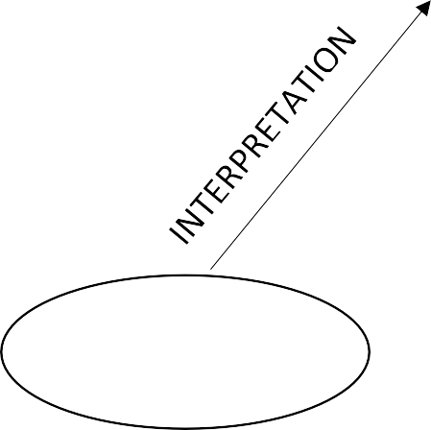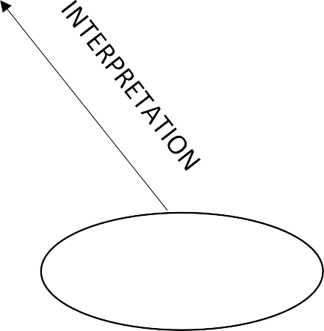

**CLIENT**

**WEB BROWSER**

Requested Page

**RENDERING**

**ENGINE**

**CSS CODE**

**HTML CODE**

**SERVER**

**WEB SERVER**

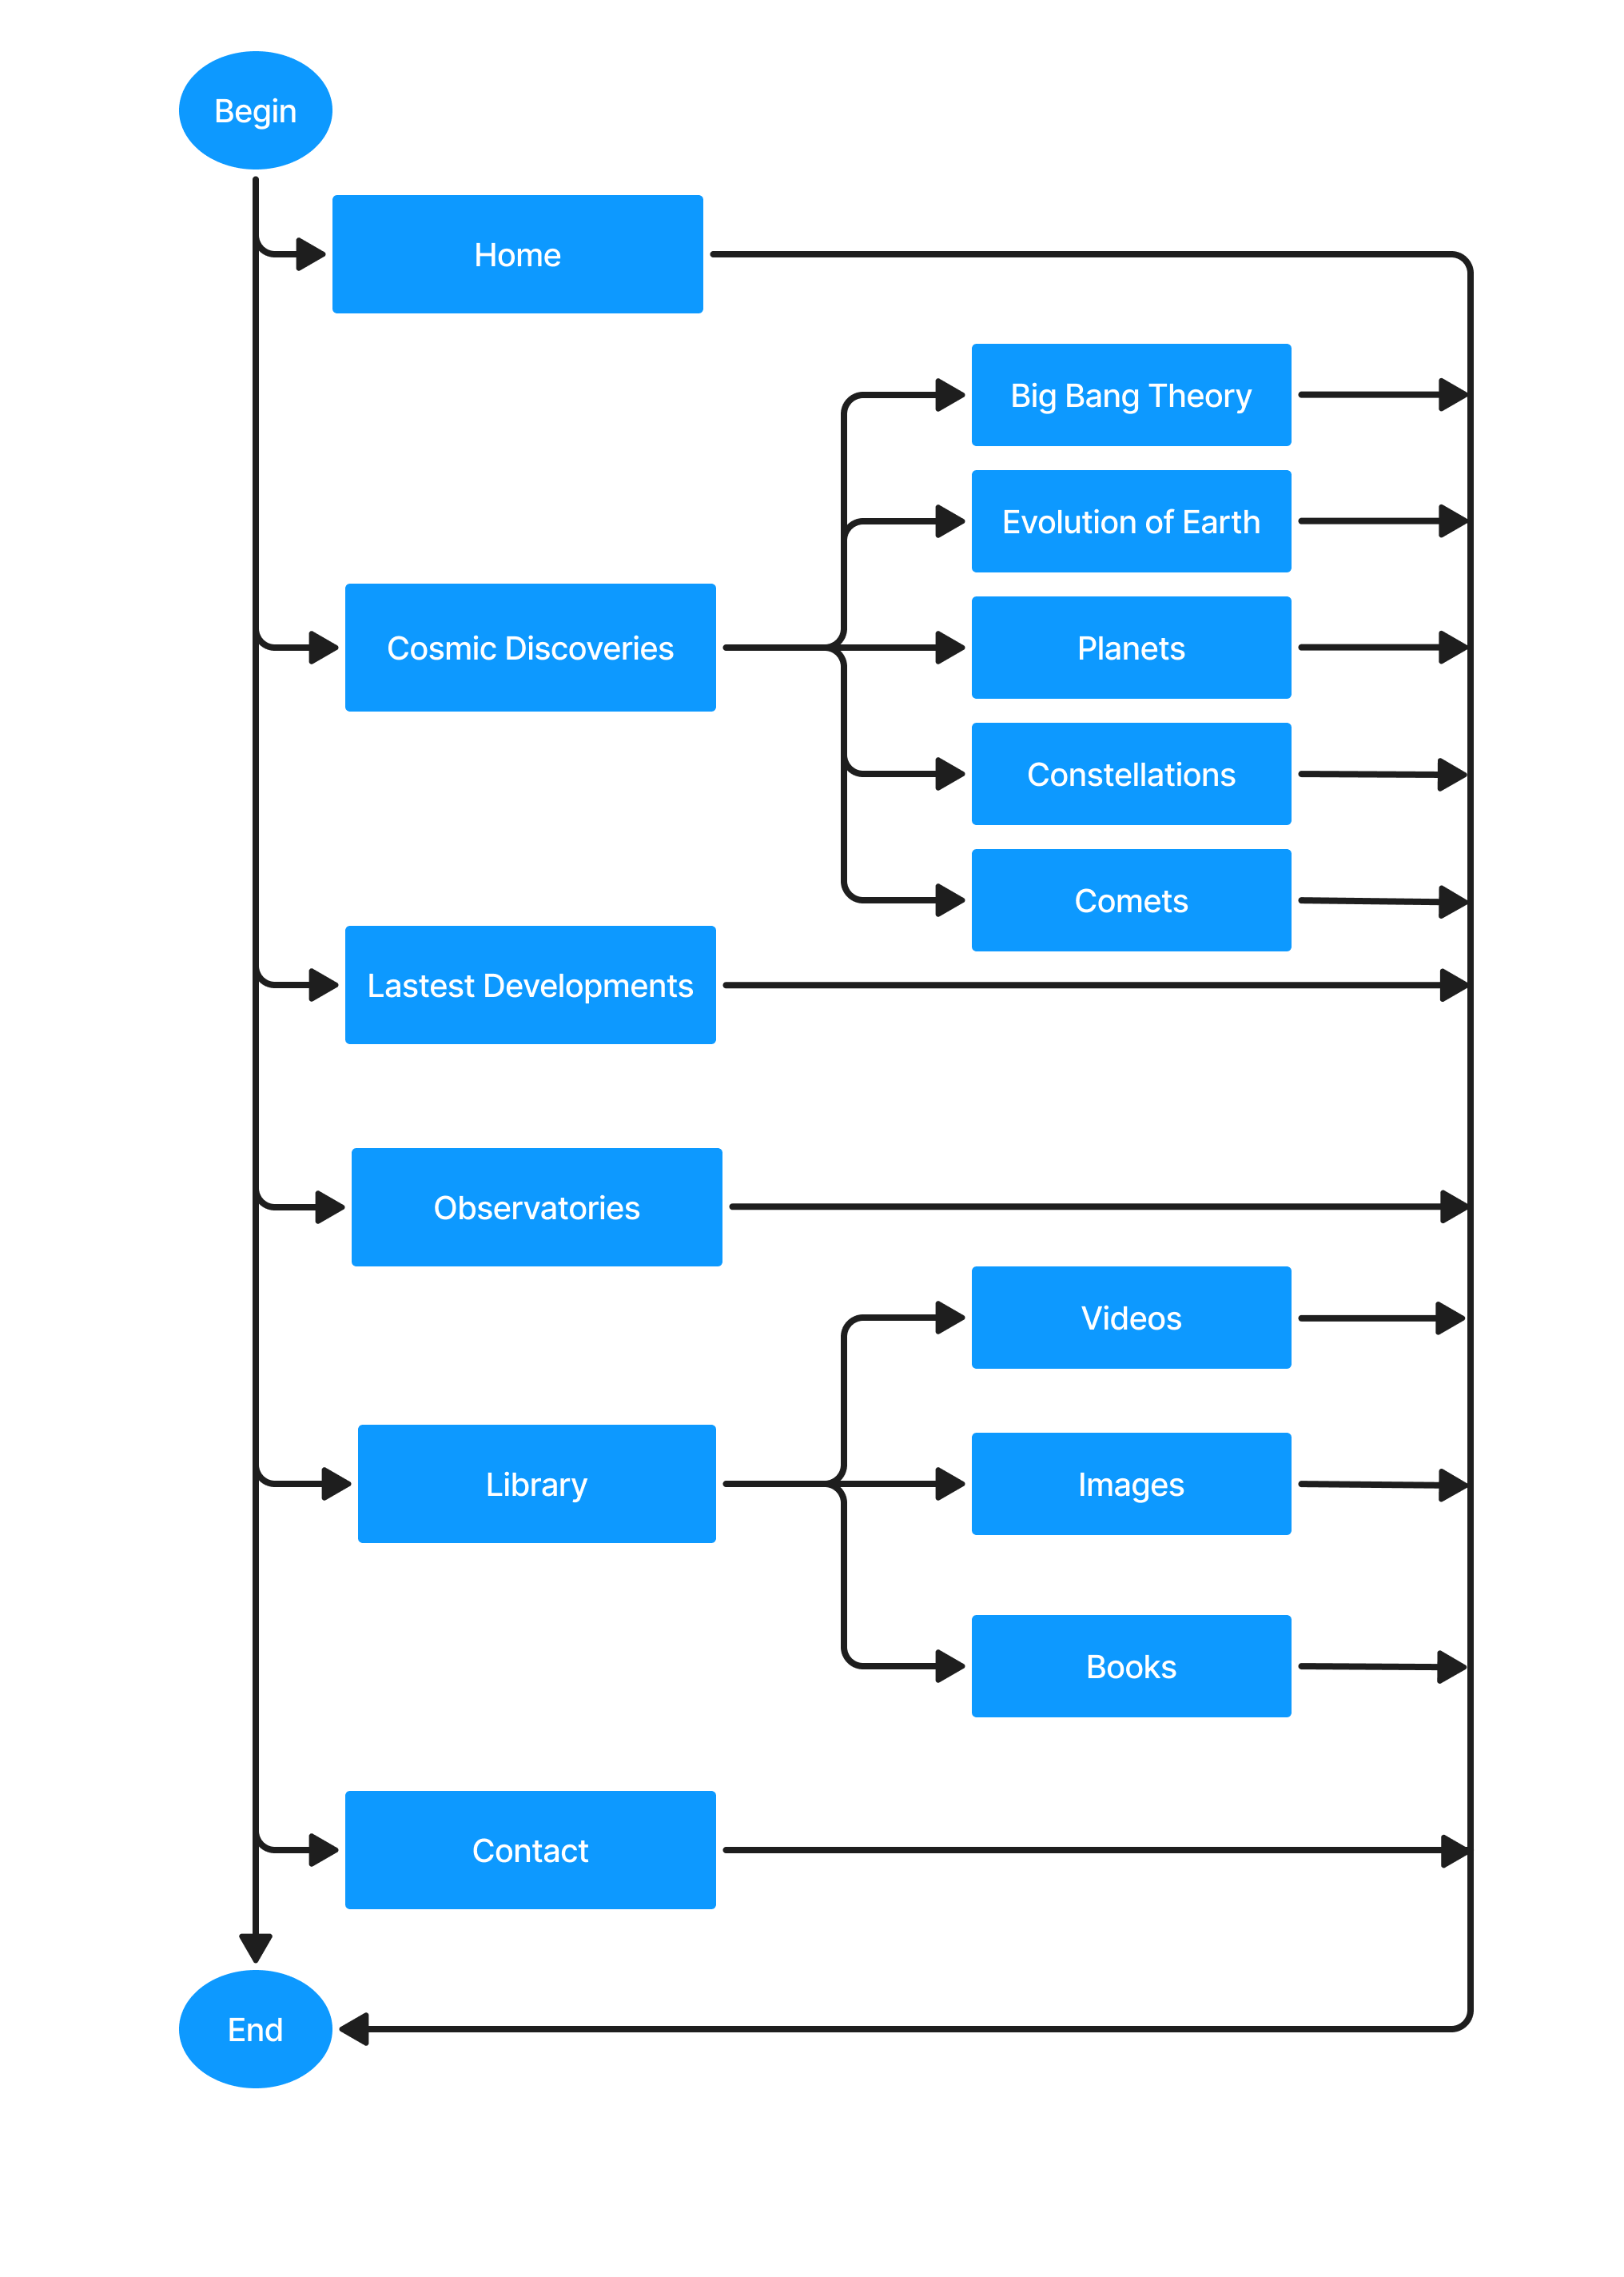



**DIAGRAM OF THE WEBSITE**



**TASK SHEET REVIEW 1**

|  |  |  |  |  |  |  |  |
| --- | --- | --- | --- | --- | --- | --- | --- |
| **Project Ref. No.: eP/Advertisement Portal Management System/01** | | **Project Title:** | **Activity Plan Prepared By:** | **Date of Preparation of Activity Plan:** | | | |
| **Sr.No** | **Task** | **Actual Start Date** | **Actual Days** | **Team Mate Names** | **Status** |
| 1 | Synopsis | The Cosmic Discoveries | Huy | 14/09/24 | 2 | Khanh | Completed |
| 2 | Analysis | 14/09/24 | 2 | Anh | Completed |
| 3 | The scope of the work (in brief) | 14/09/24 | 2 | Huy | Completed |
| 4 | Architecture and design of the system | 21/09/24 | 4 | Khanh | Completed |
| 5 | Diagram of the website | 21/09/24 | 4 | Anh | Completed |
| 6 | Task Sheet Review | 21/09/24 | 4 | Huy | Completed |

|  |  |
| --- | --- |
| **Date:** | |
| Signature of Instructor:  **Le Mong Thuy** | Signature of Team Leader:  **Le Nguyen Gia Huy** |

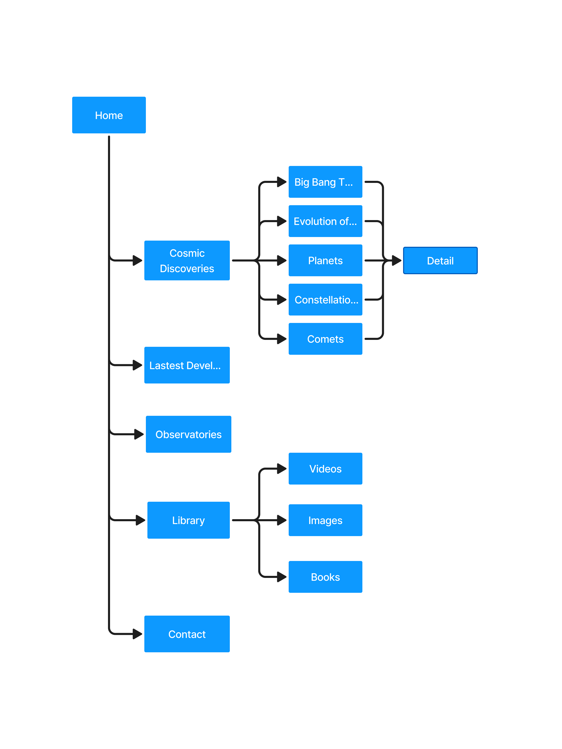



**SITE MAP**

## MOCK OF THE WEBSITE

### Home

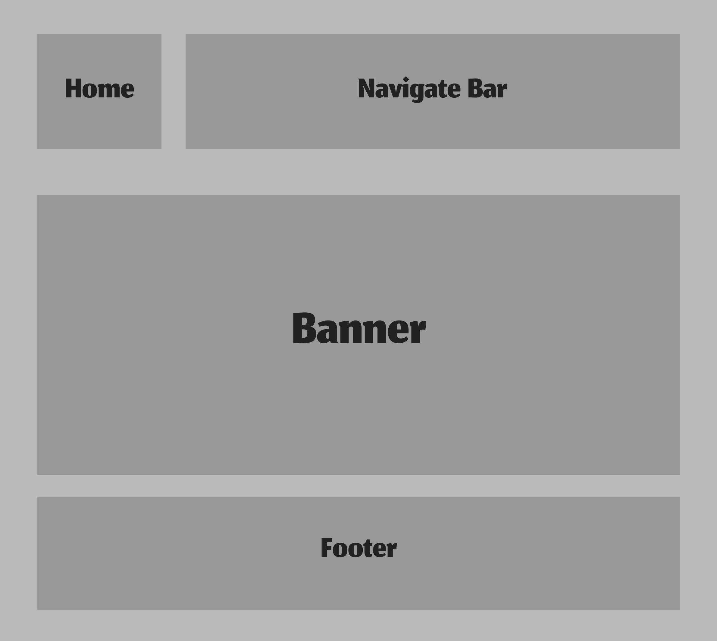

### Cosmic Discoveries

* 1. **Big Bang Theory**
  2. **Evolution of Earth**
  3. **Planets**
  4. **Constellations**
  5. **Comets**

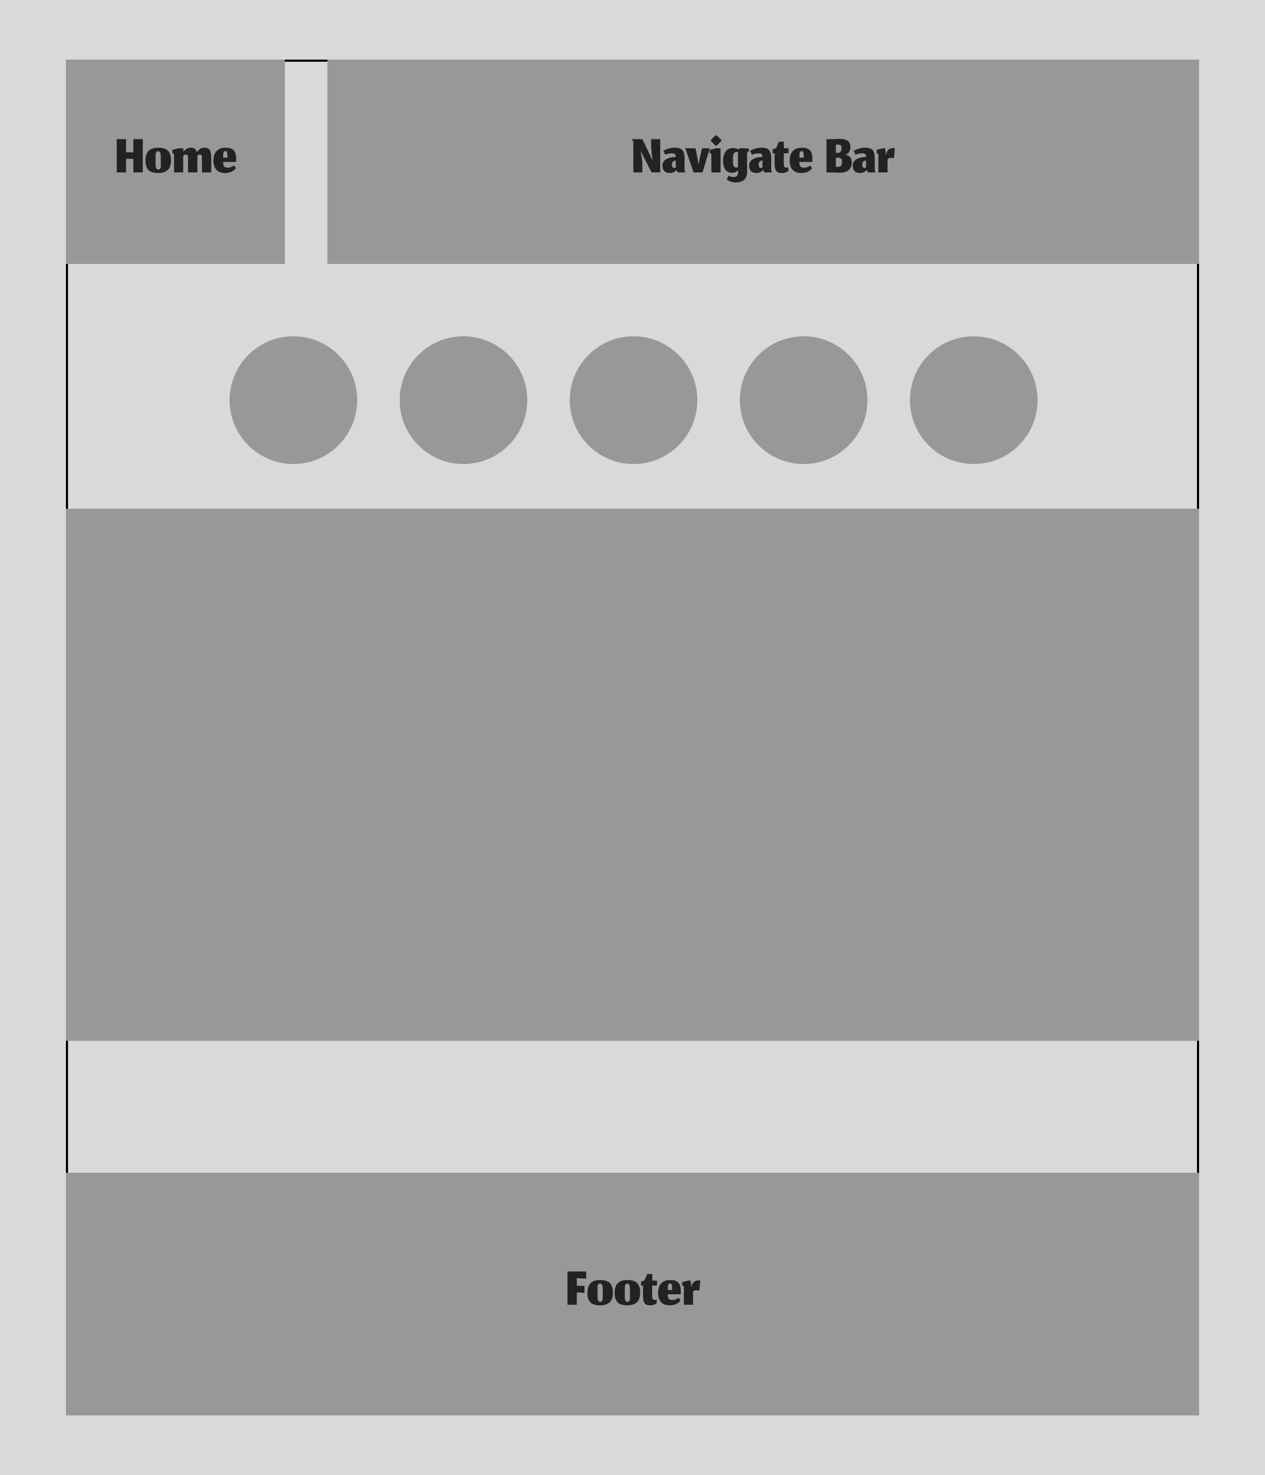

### Latest Developments

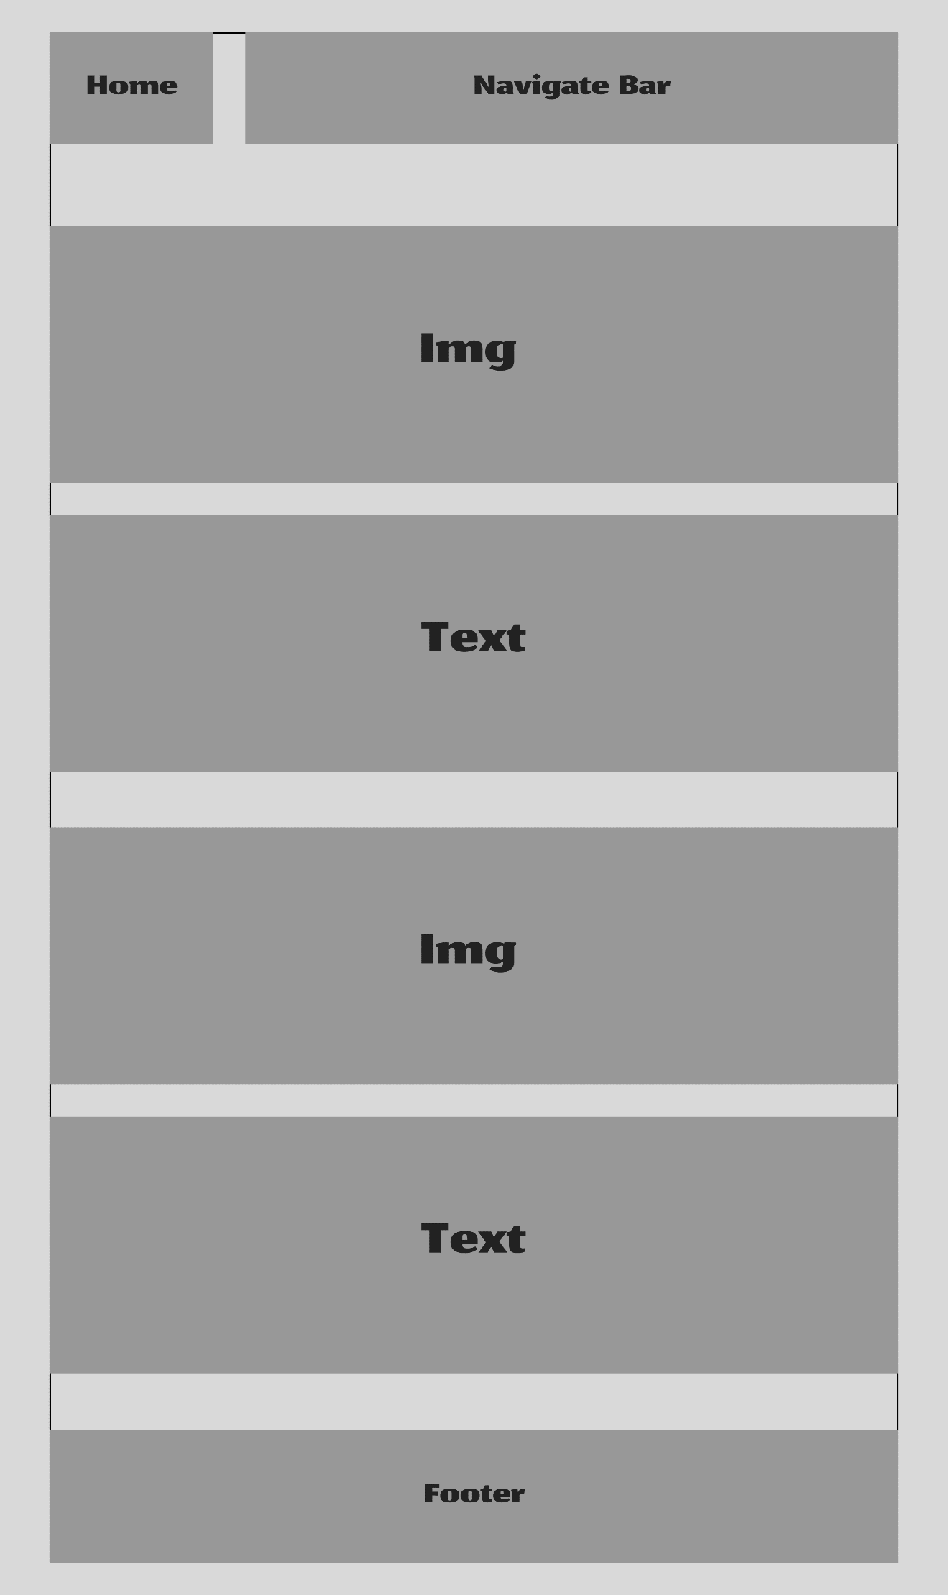

**COMPARE PAGE**

### Observatories:

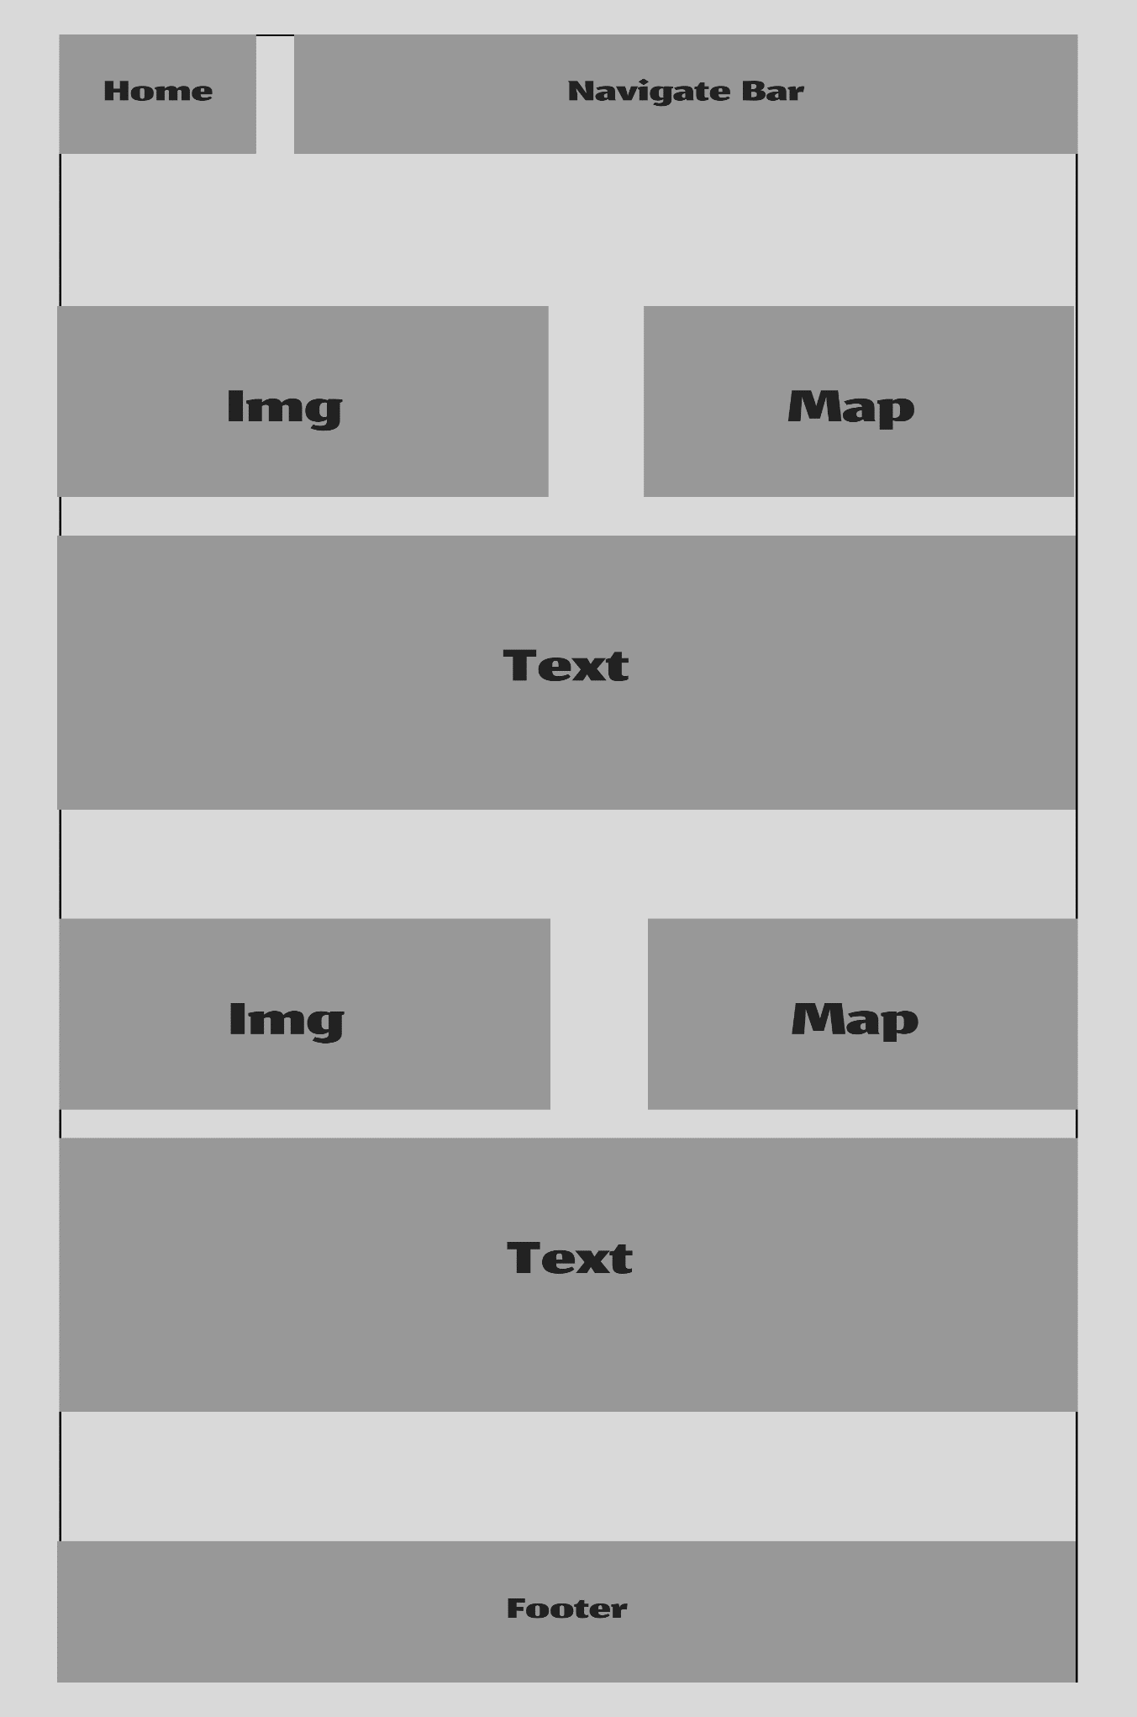

1. **Libraries**

**COMPARE PAGE**

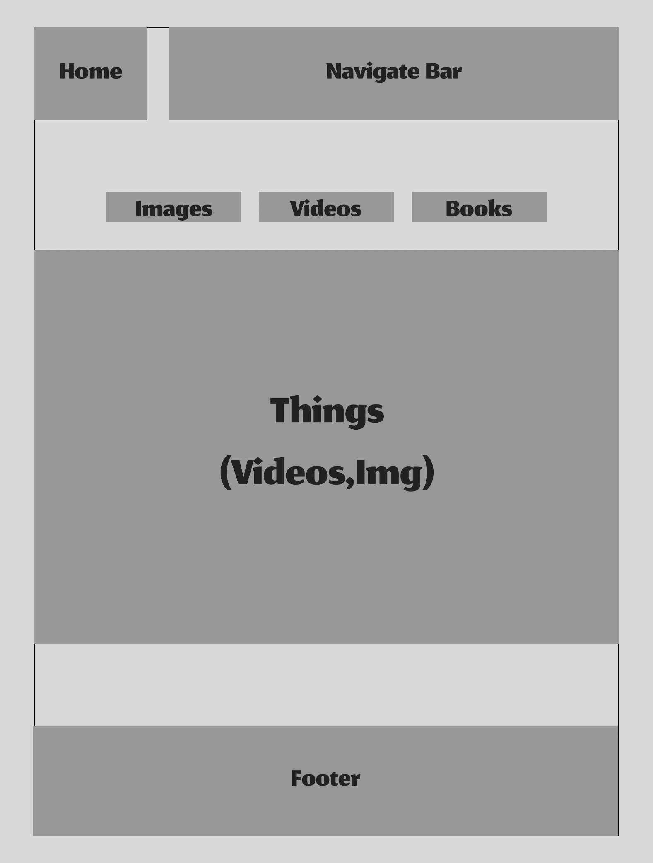

1. **Contact**

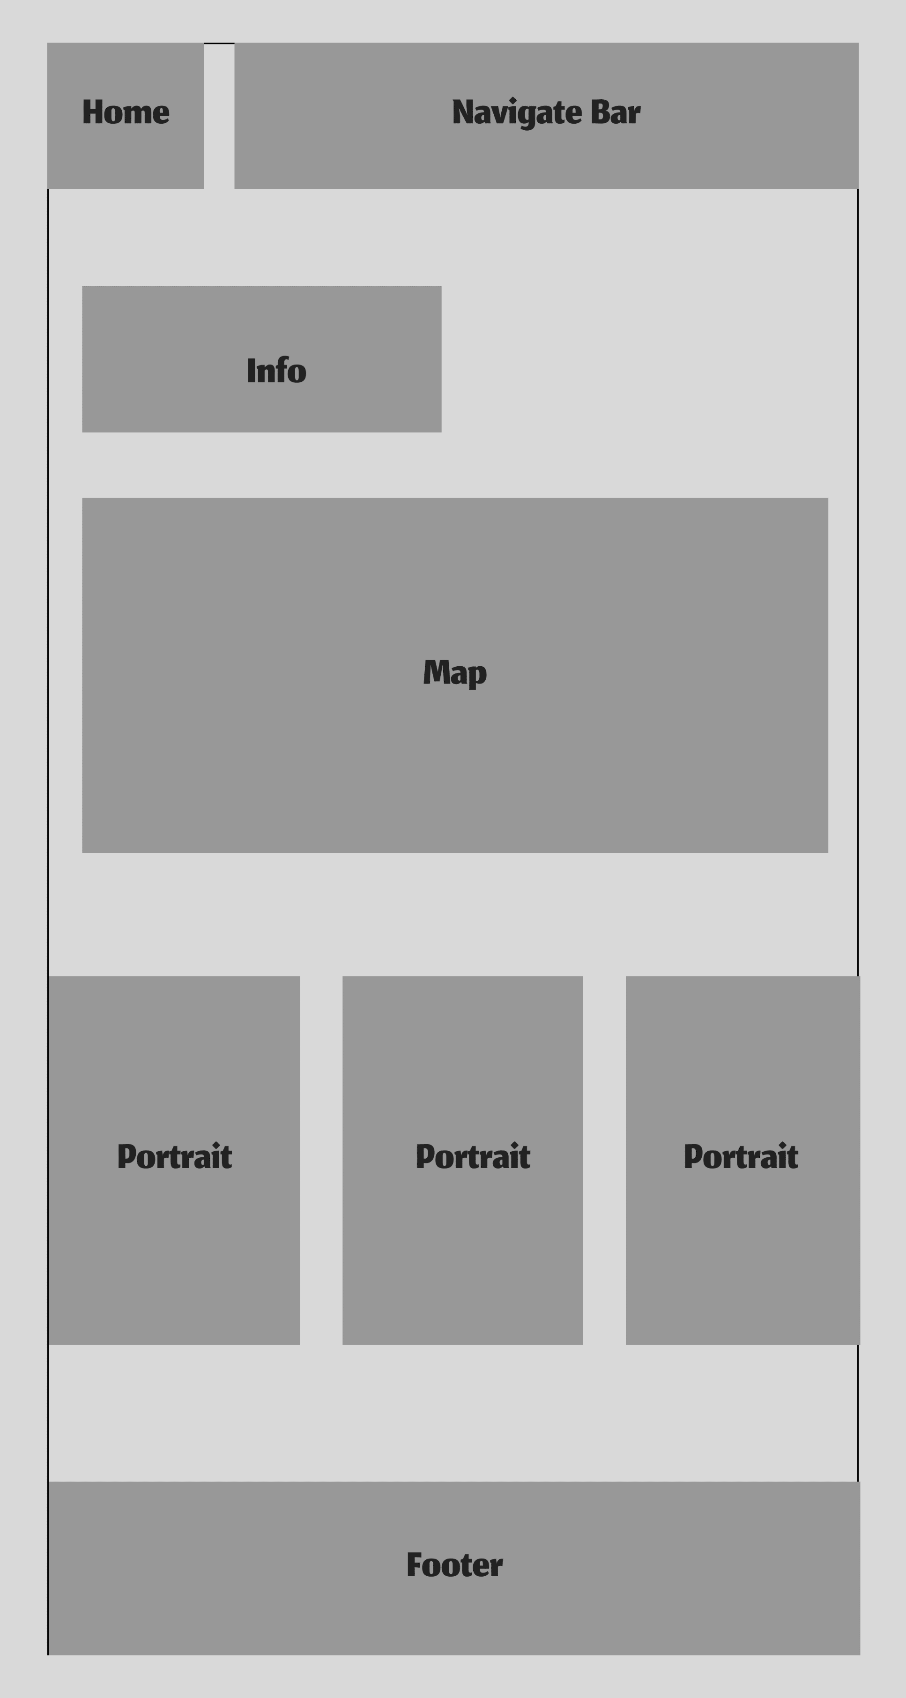



**TASK SHEET REVIEW 2**

|  |  |  |  |  |  |  |  |
| --- | --- | --- | --- | --- | --- | --- | --- |
| **Project Ref. No.: eP/Advertisement Portal Management System/01** | | **Project Title:** | **Activity Plan Prepared By:** | **Date of Preparation of Activity Plan:** | | | |
| **Sr.No.** | **Task** | **Actual Start Date** | **Actual Days** | **Team Mate Names** | **Status** |
| 1 | Site map | The Cosmic Discoveries | Huy | 25/9/24 | 7 | Khanh, Dung | Completed |
| 2 | Mock of website | 25/9/24 | 7 | Anh | Completed |
| 3 | Task sheet Review | 25/9/24 | 7 | Huy | Completed |

|  |  |
| --- | --- |
| **Date: 27/06/2024** | |
| Signature of Instructor:  **Ms. Le Mong Thuy** | Signature of Team Leader:  **Le Nguyen Gia Huy** |

# Problem Defination

## 1. Requirement 1:

Home Page

### 

### 

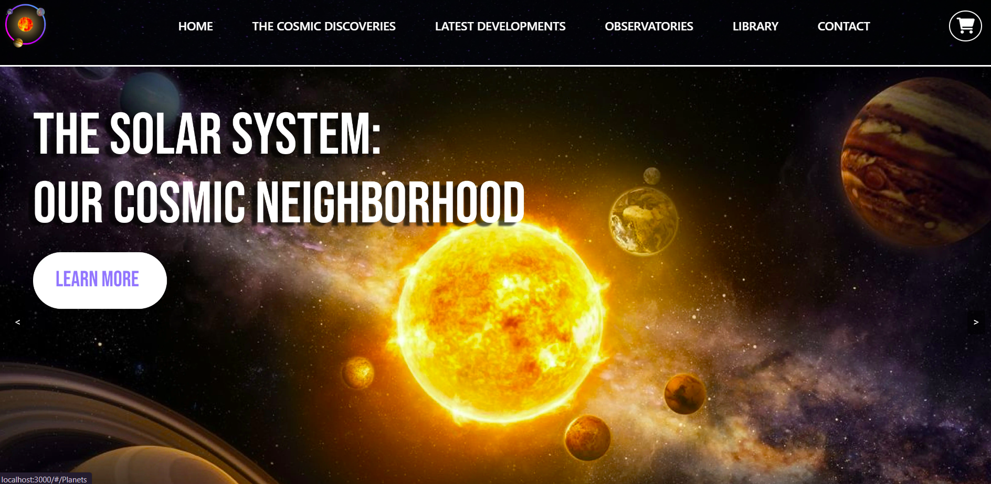 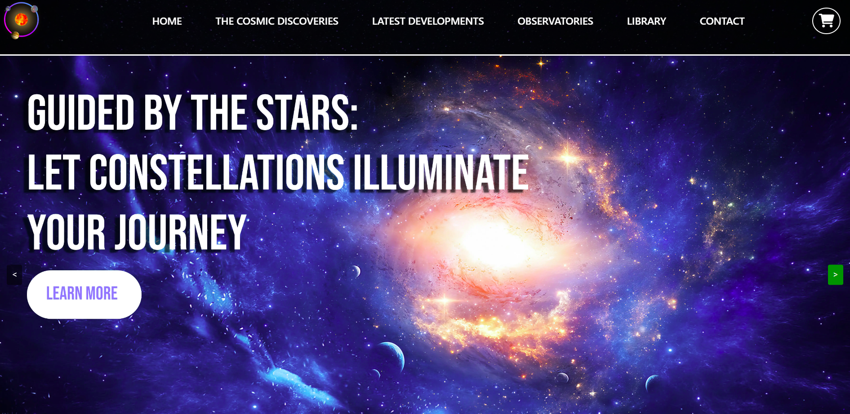  
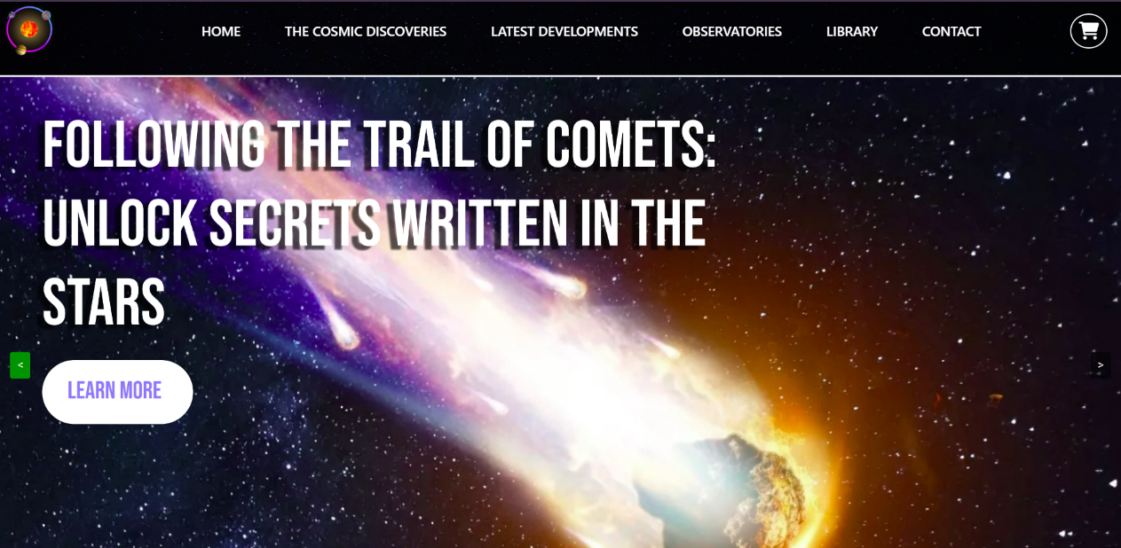

## 

## 2.Requirement 2:

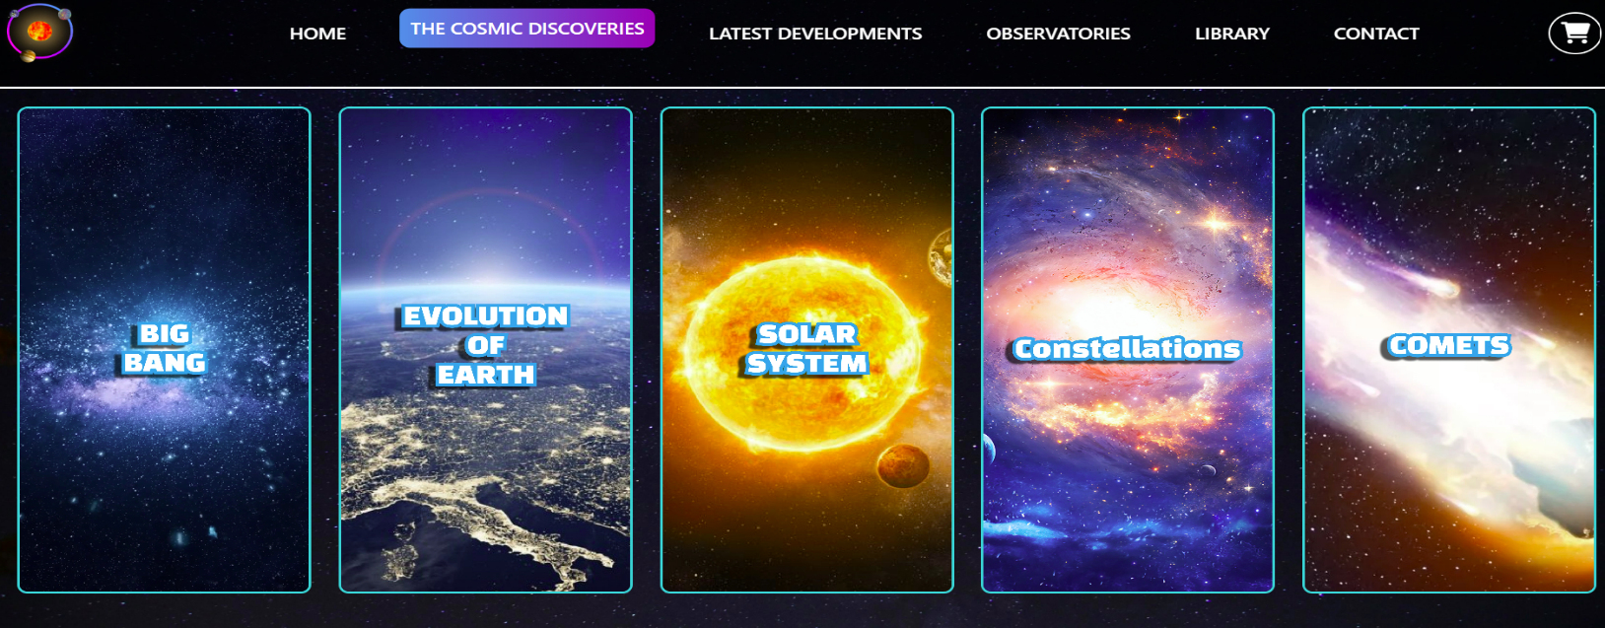Categories Section:

### *2.1. Big Bang Theory:*

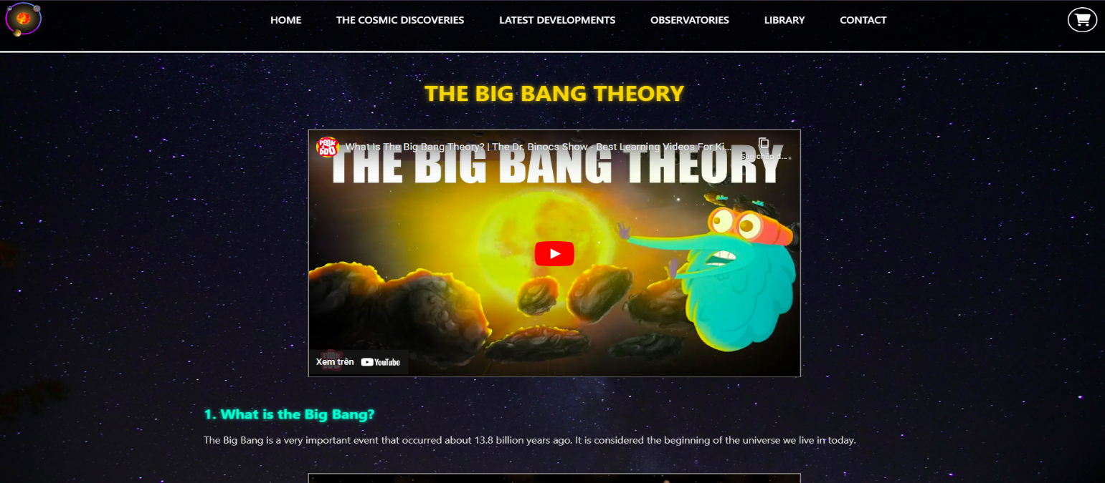

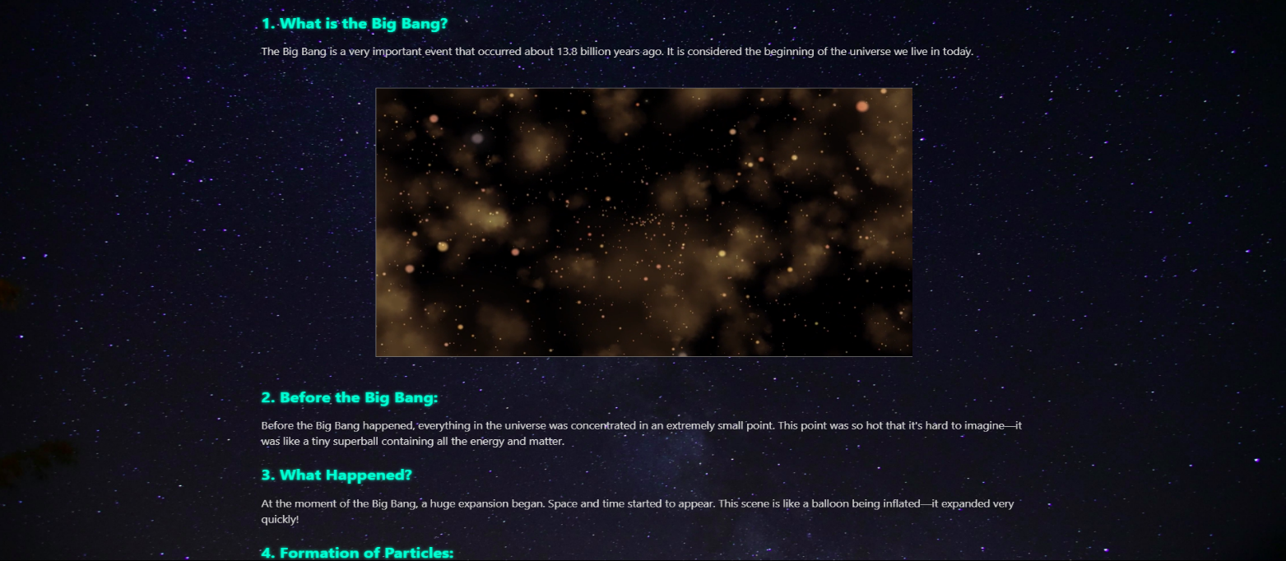

### 

### *2.2 Evolution of Earth:*

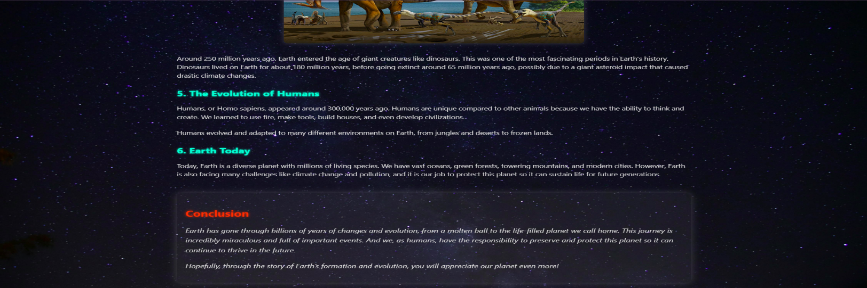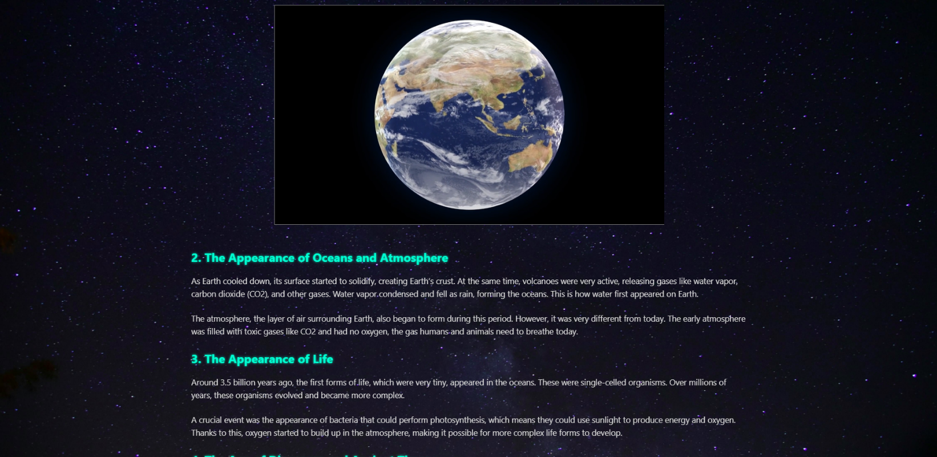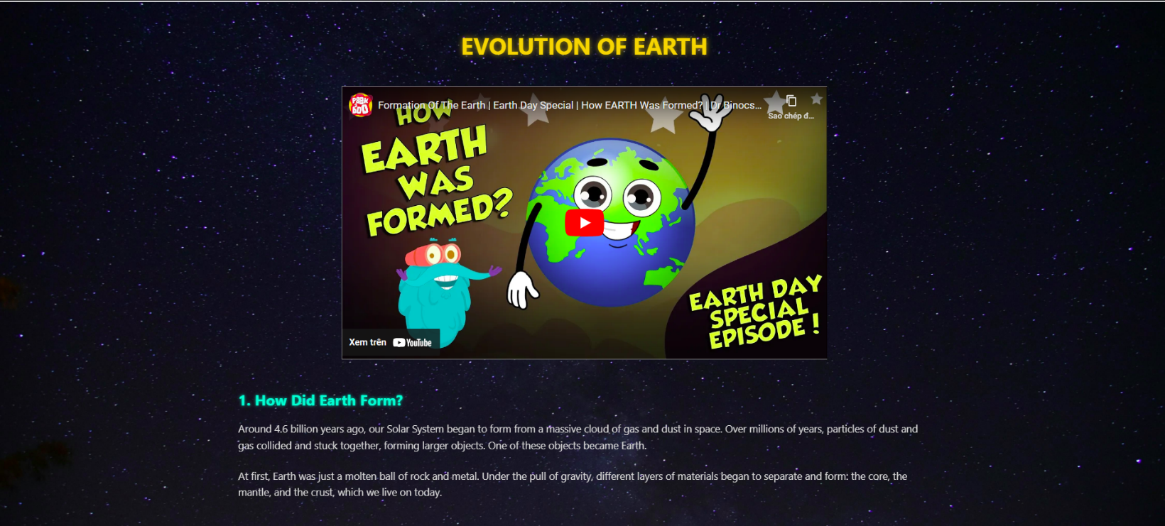

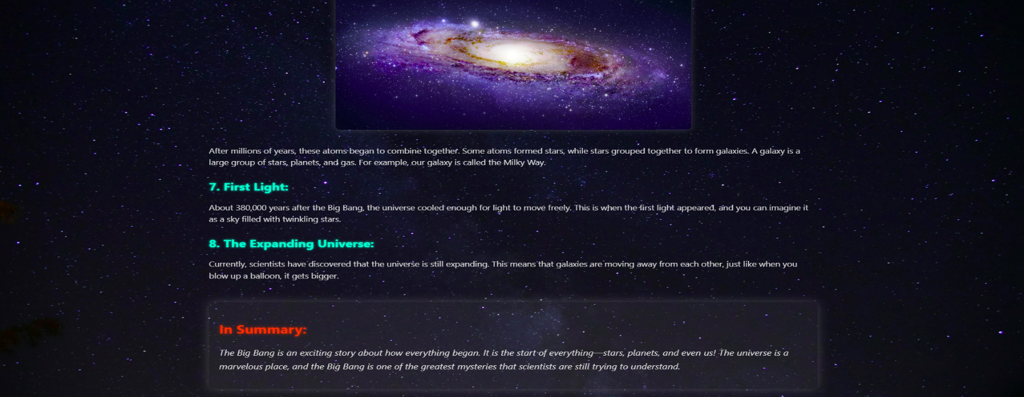

## 3. Requirement 3:

### Planets Section

### 

## 4. Requirement 4:

## Constellations Section

### 

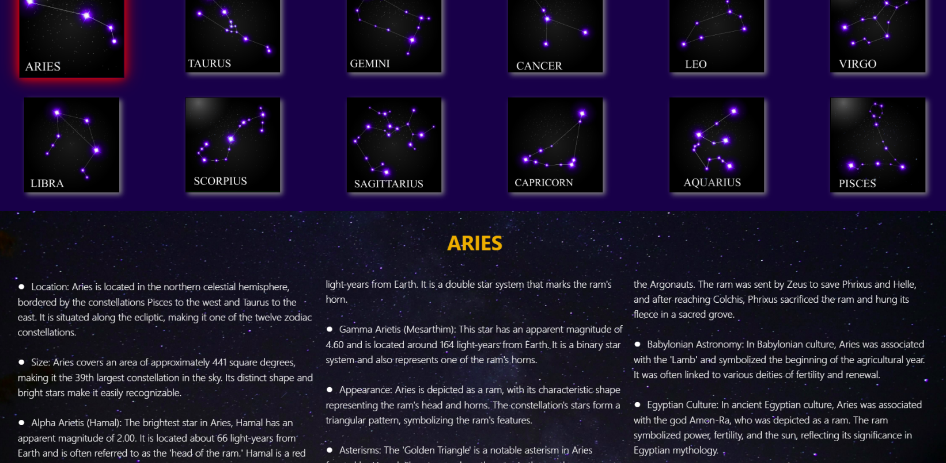

## 5. Requirement 5:

Comets Section

### 

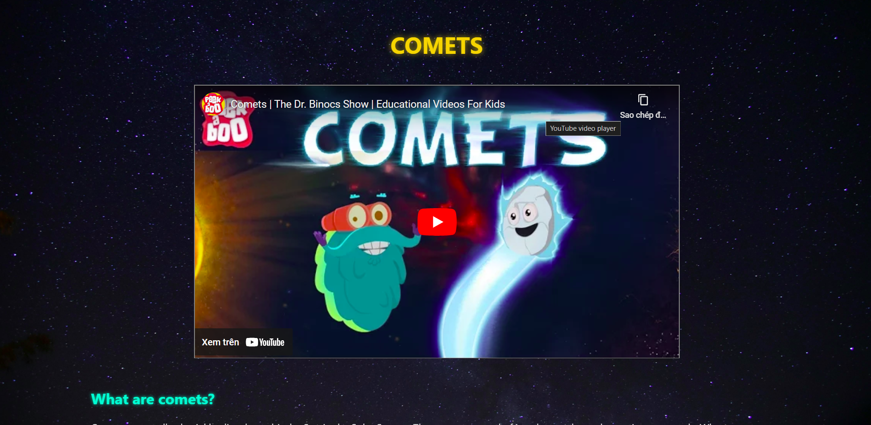

### 

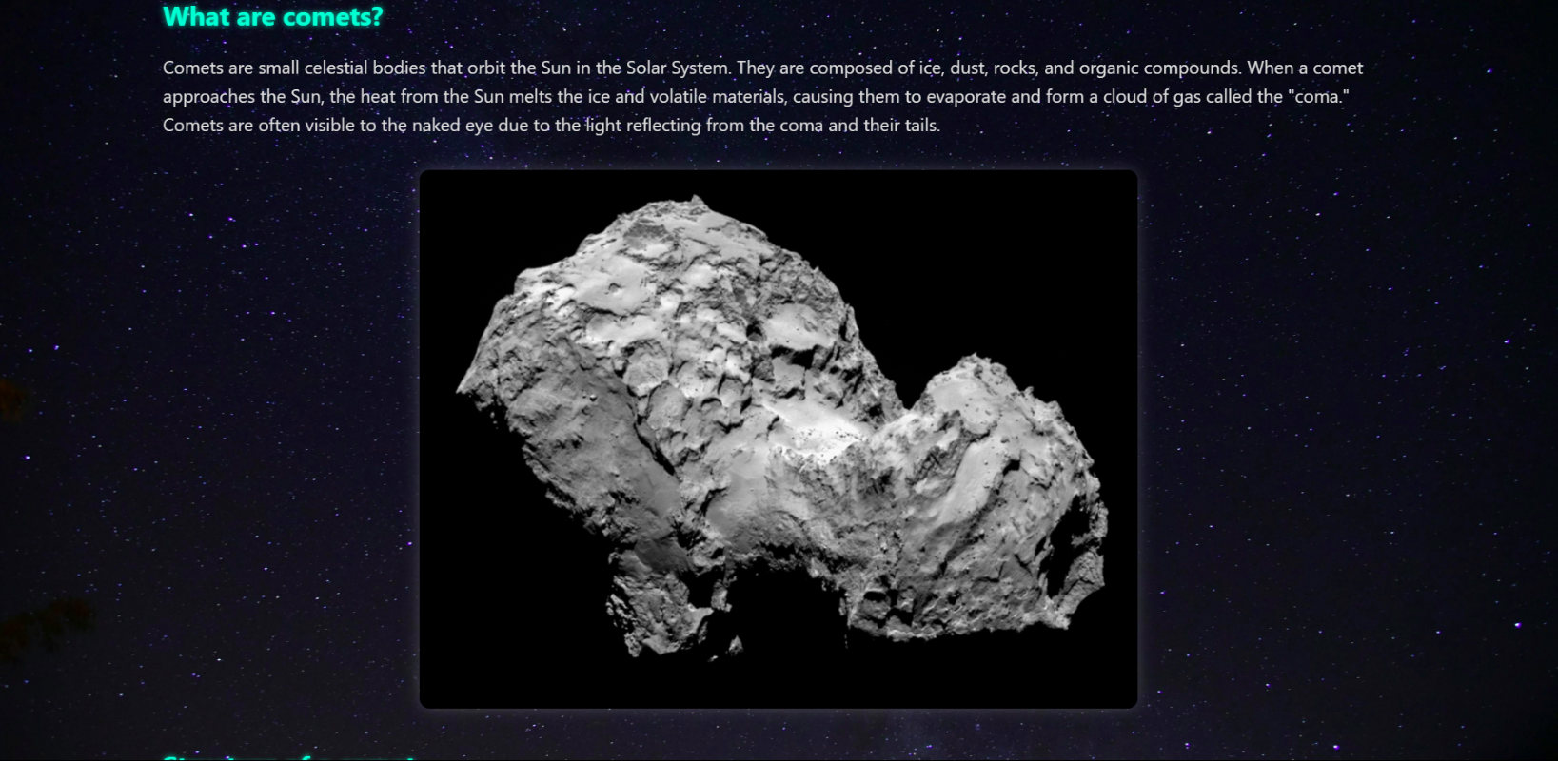

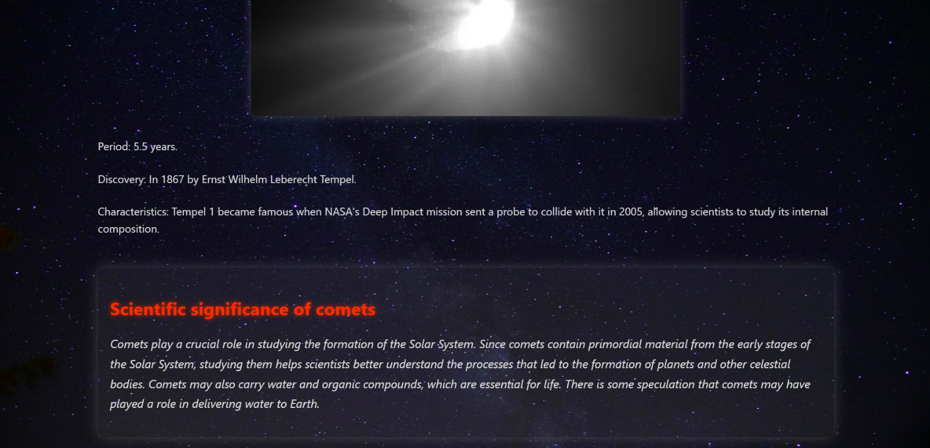

## 6. Requirement 6:

Latest Developments

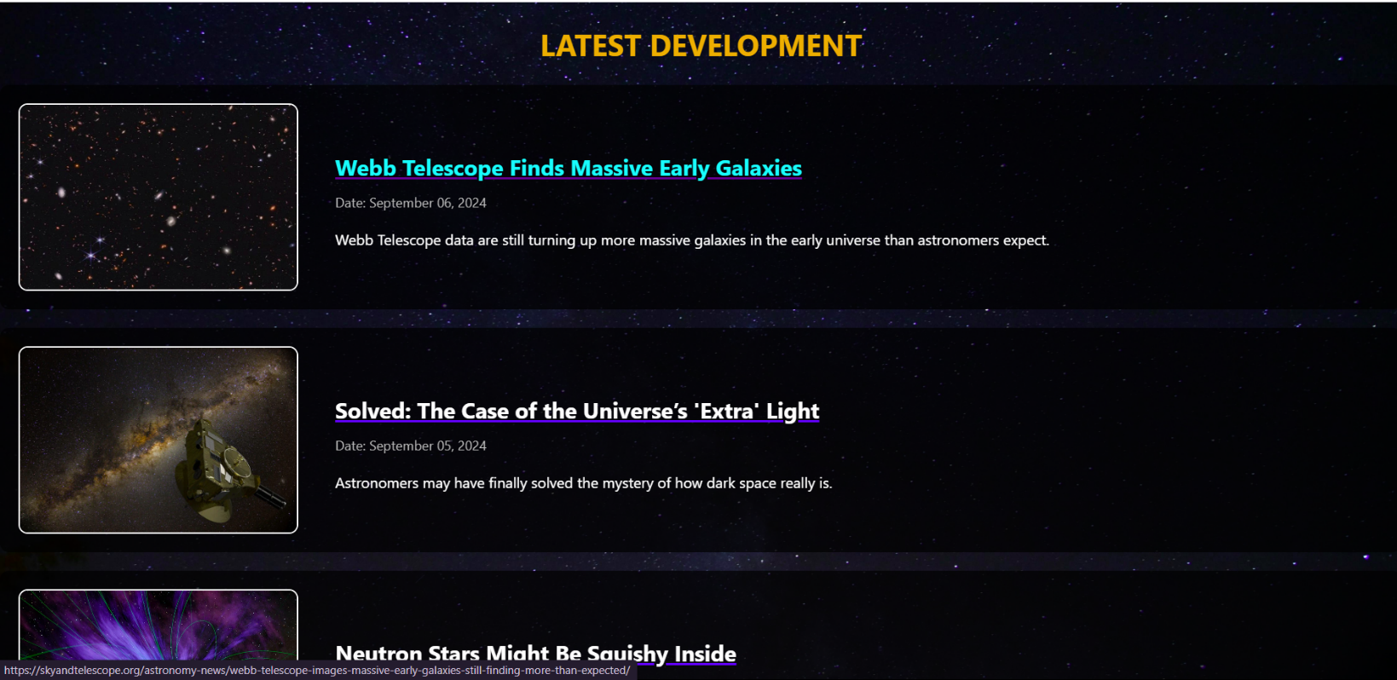

### 

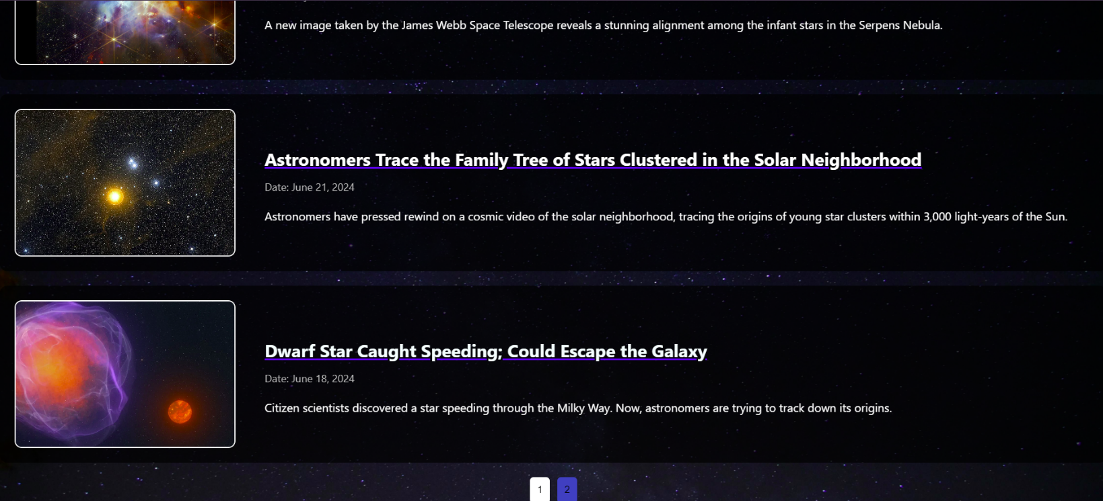

## 7. Requirement 7:

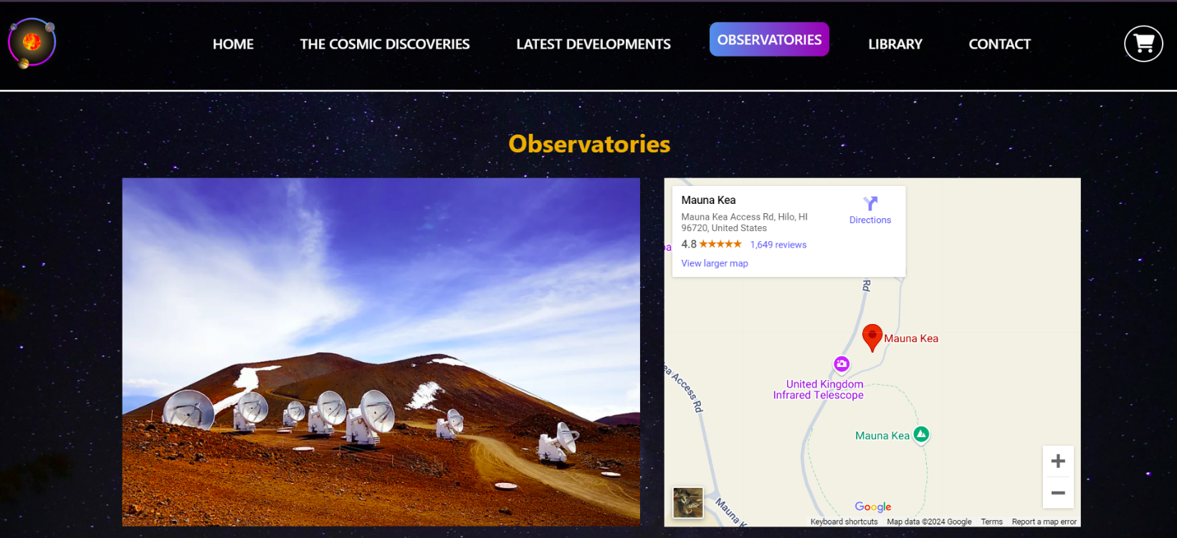Observatories Section

### 

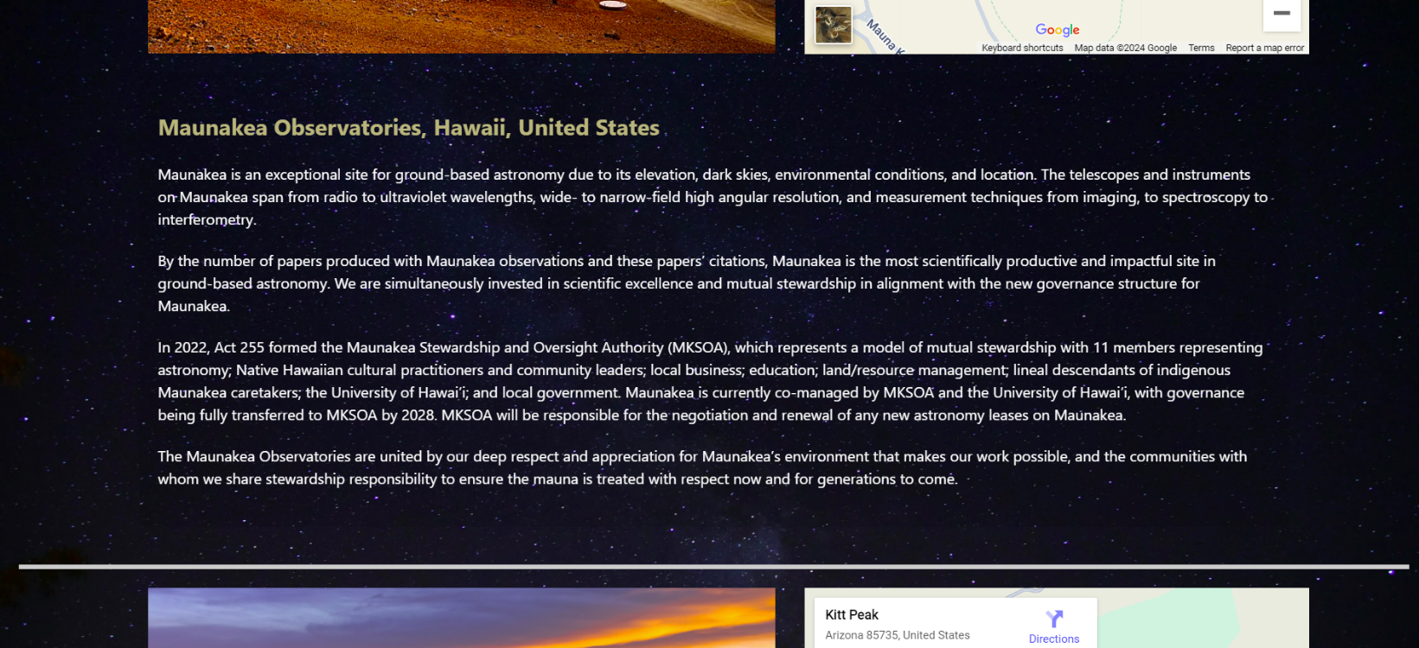

## 8.Requirement 8:

## Educational Videos :

### 8.1. Images:

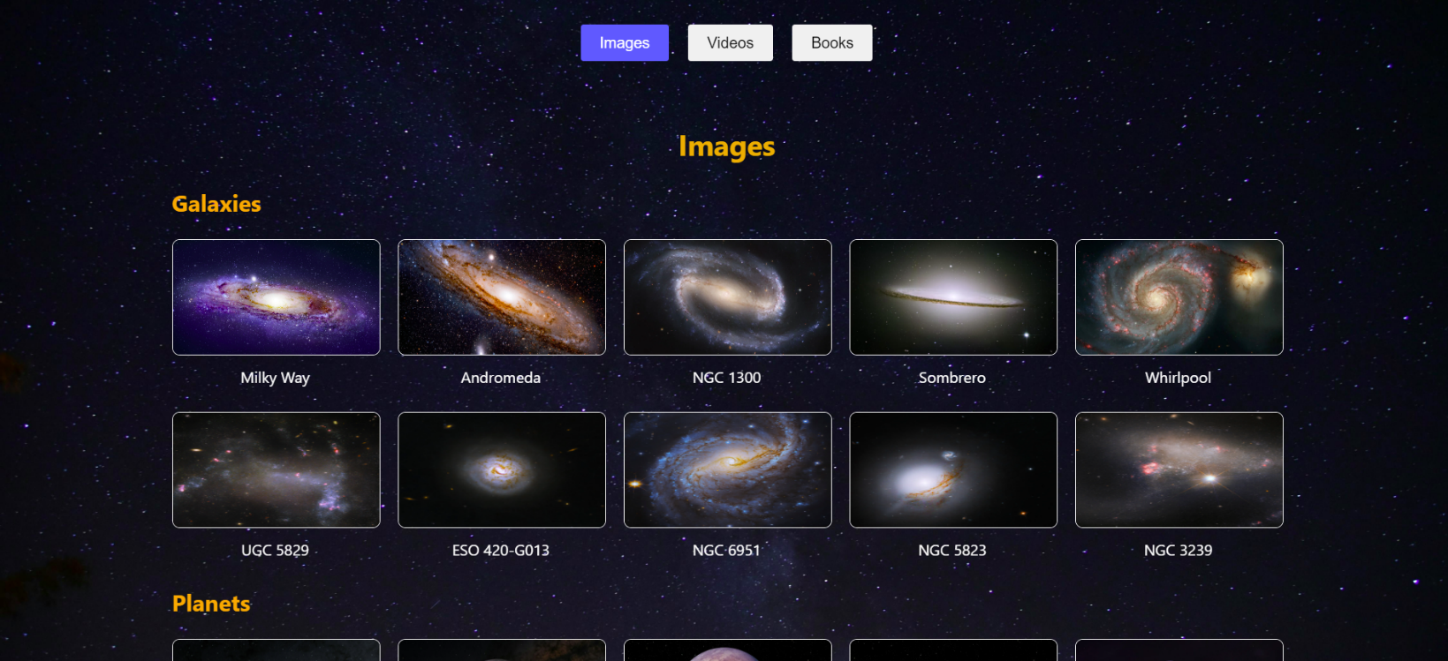

8.2. Videos:

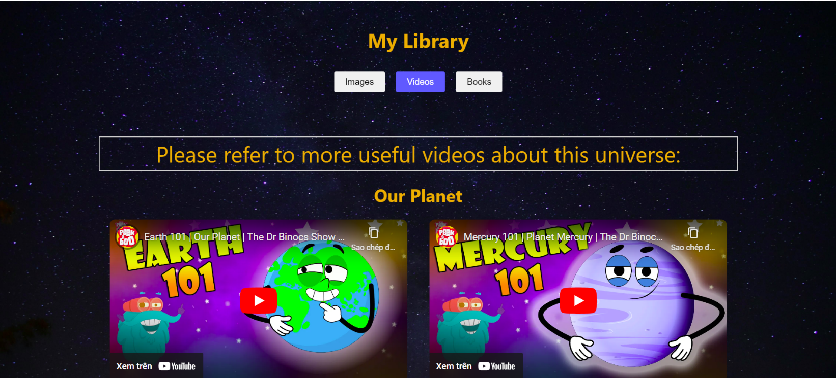

## 9. Requirement 9: Related Books

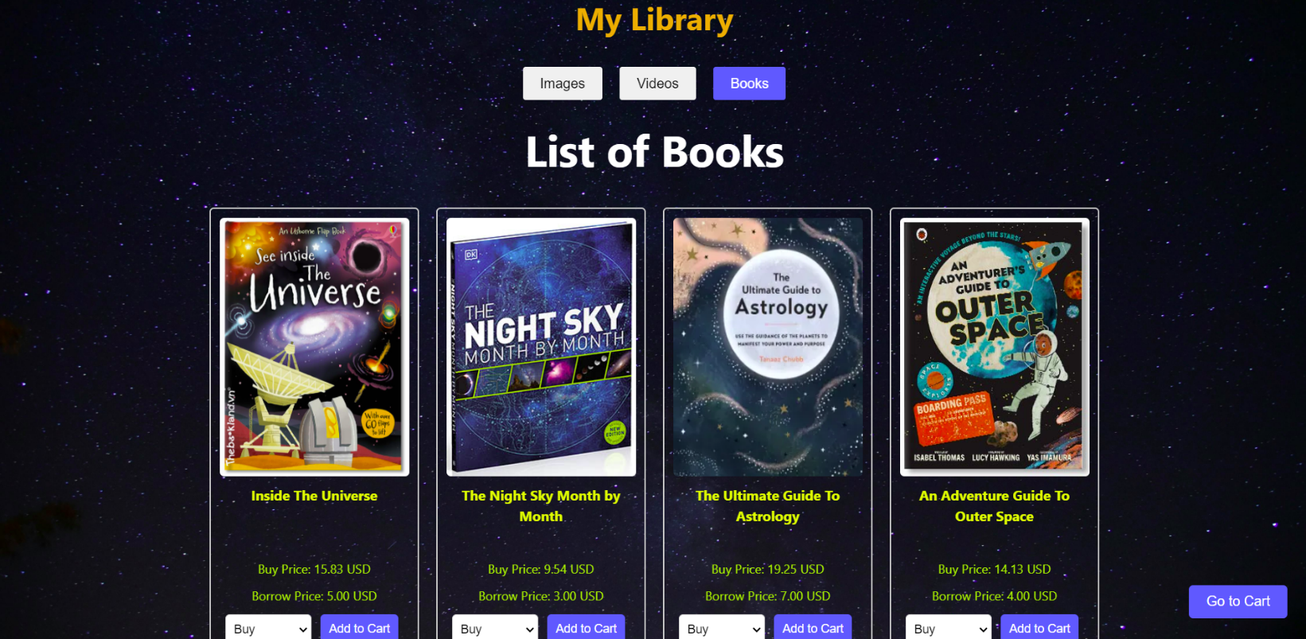

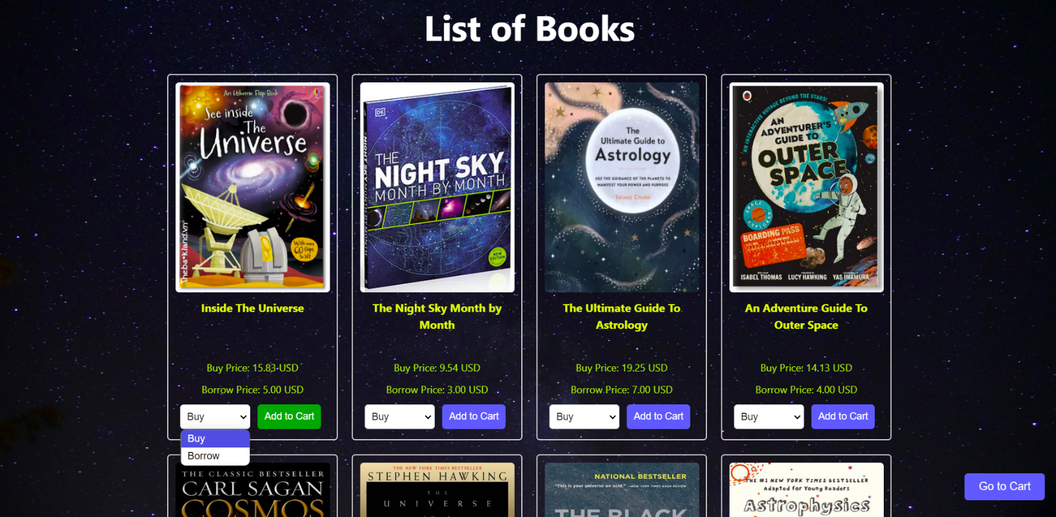



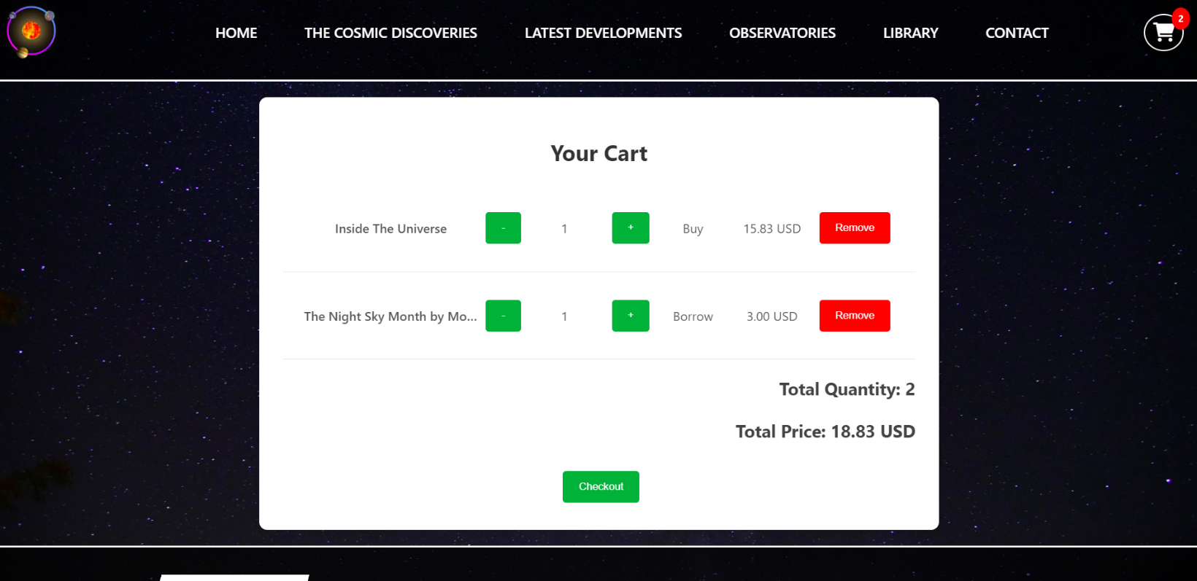

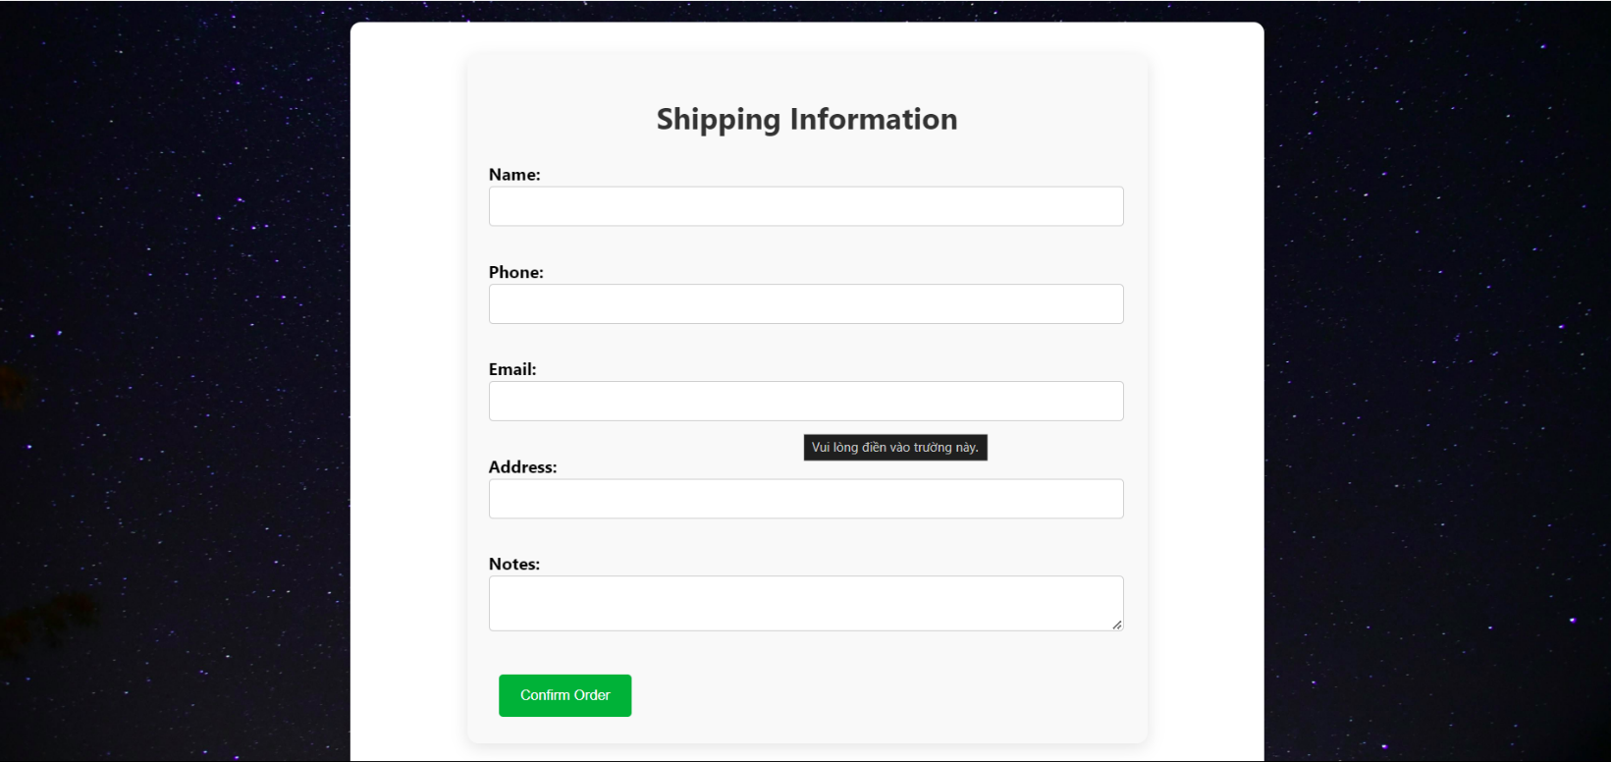



## 10. Requirement 10:

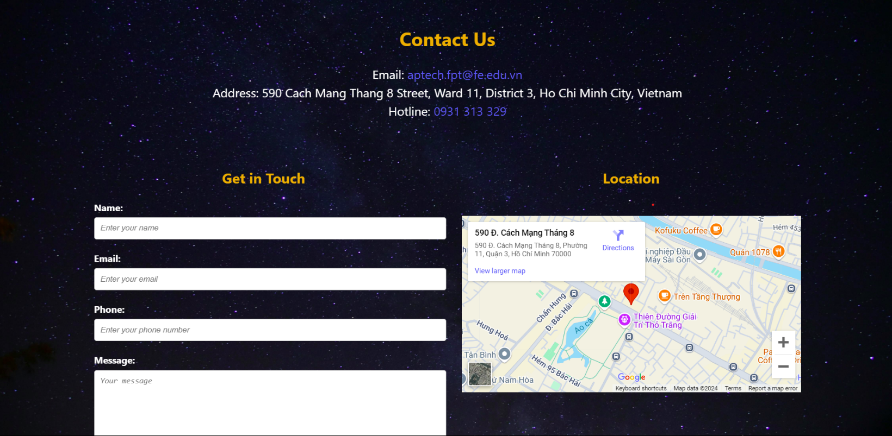 About Us &amp; Contact Us

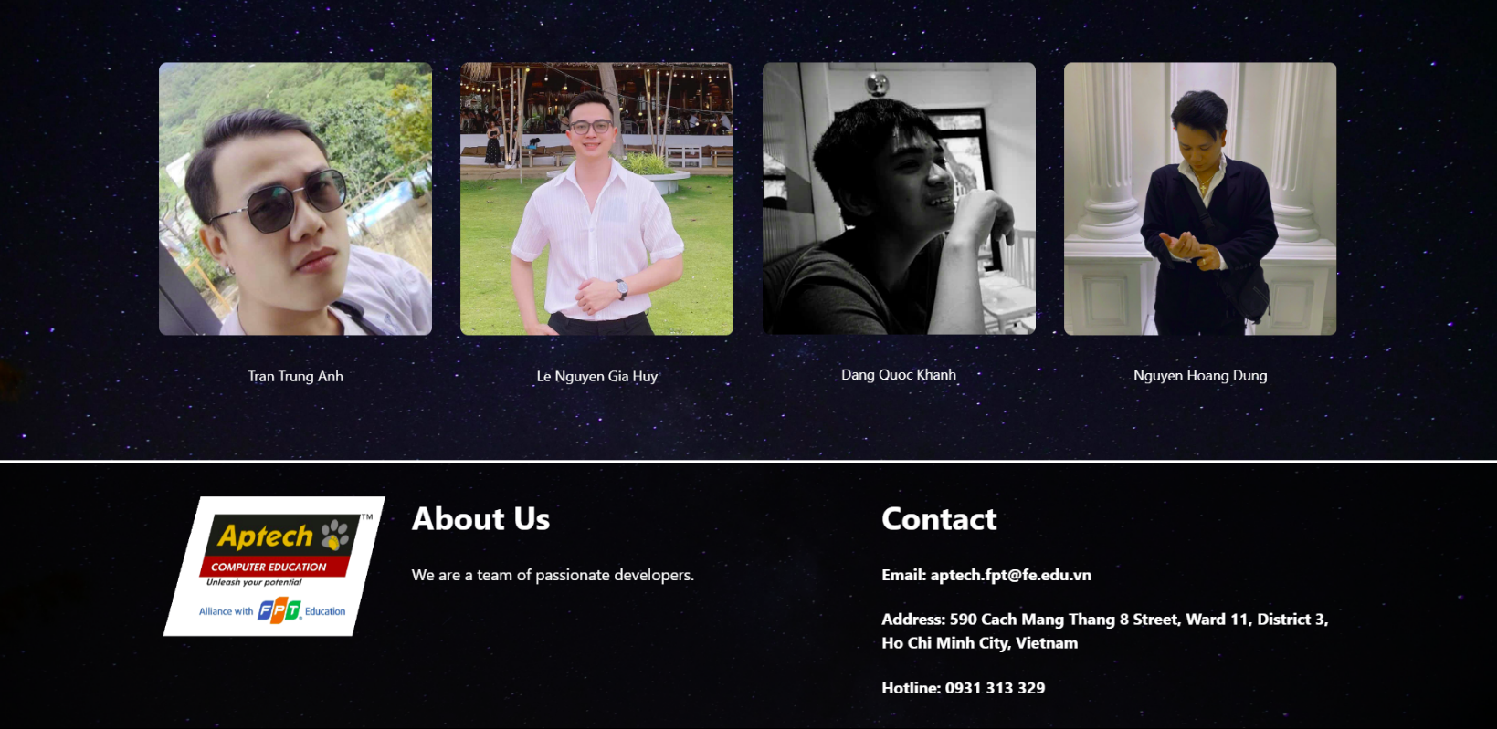

# Task Sheet Review 3

|  |  |  |  |  |  |  |  |
| --- | --- | --- | --- | --- | --- | --- | --- |
| **Project Ref. No.: eP/Advertisement Portal Management System/01** | | **Project Title:** | **Activity Plan Prepared By:** | **Date of Preparation of Activity Plan:** | | | |
| **Sr.No.** | **Task** | **Actual Start Date** | **Actual Days** | **Team Mate Names** | **Status** |
| 1 | Website Layout | *The Cosmic Discoveries* | Huy | 10/10/24 | 1 | Huy,  Anh,  Khanh, Dung | Completed |
| 2 | Report | 1 | Completed |
| 3 | Task sheet Review 3 | 1 | Completed |

|  |  |
| --- | --- |
| **Date: 01/10/2024** | |
| Signature of Instructor:  **Ms. Le Mong Thuy** | Signature of Team Leader:  **Le Nguyen Gia Huy** |